Exception Handling (OR) Error Handling

In application development we come across 3 types of errors.

Types of Errors
- Compile time Errors
- Logical Errors
- Runtime Errors

Compile time Errors
The errors which occur during compilation of program are called compile time errors. All syntax errors are called compile time errors.
If there is syntax error within program, program is not executed.

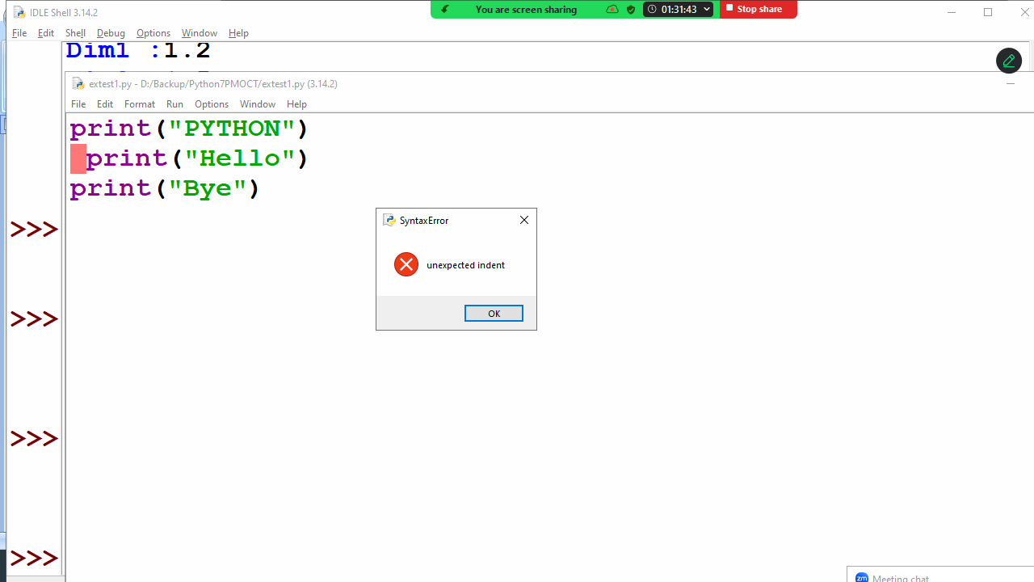
Syntax errors are rectified by programmer in order to execute program.

Logical Errors
A logical error is a programming logic error.
If there is logical error, program is executed but gives wrong result.

#Program to print sum of 2 numbers
n1=10
n2=5
n3=n1-n2 # Logical Error
print(n1,n2,n3)

Output
10 5 5

# finding max of two numbers
n1=10
n2=5
if n1>n2: # Logical Error
print(n2)
else:
print(n1)

Output
5

Logical errors are rectified by programmer in order to give accurate result.

Runtime Errors
The errors which occur during execution of program are called runtime errors.
Runtime error occurs because of wrong input given to the program.

# division of two numbers
a=int(input("Enter First integer value :"))
b=int(input("Enter Second integer value :"))
c=a/b
print(a,b,c)

Output
Enter First integer value :12
Enter Second integer value :4
12 4 3.0

Enter First integer value :5
Enter Second integer value :0
Traceback (most recent call last):
File "D:/Backup/Python7PMOCT/extest2.py", line 4, in <module>
c=a/b
ZeroDivisionError: division by zero

What is exception?
Exception is a runtime error.
Exception is an error which occurs during the execution of program.
Exception is occurred because of wrong input given to program or function.
Whenever exception is occurred program execution is terminated.
Exception handling is a mechanism used to handle runtime errors or exceptions.

Advantage of exception handling
- Avoiding abnormal termination program
- Converting predefined error messages into user defined error messages (OR) converting technical error messages into user friendly error messages

Exception handling is done using the following keywords
- try
- except
- finally
- raise

Every exception is a class or data type, and generating exception is nothing but creating object of exception class/error class giving to python virtual machine.

Error types or exceptions are 2
- Predefined error types or classes
- User defined error types or classes

Errors are generated by functions.
Predefined functions of python generate predefined errors.
Example: ValueError, IndexError, KeyError, ZeroDivisionError, TypeError
Every error type is one class or data type, which inherits the properties of Exception class
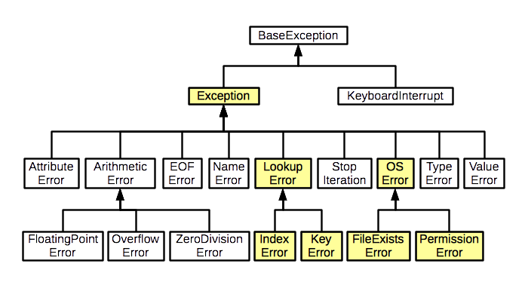
try block
try block contains the statements which generates error
The statements which have to monitor for error handling or exception handling are written inside try block.

Syntax:
try:
statement-1
statement-2

except block
except block is error handler block
if there is an error inside try block, it is handled using except block.
Try block followed by one or more than one except block.

Syntax:
try:
statement-1
statement-2
except exception-type:
statement-3
except exception-type:
statement-4

Example:
# Write a program to divide 2 numbers

while True:
n1=int(input("Enter first number :"))
n2=int(input("Enter second number :"))
try:
n3=n1/n2
print(n1,n2,n3)
break
except ZeroDivisionError:
print("Cannot divide number with zero, try again")

Output
Enter first number :5
Enter second number :0
Cannot divide number with zero, try again
Enter first number :8
Enter second number :0
Cannot divide number with zero, try again
Enter first number :4
Enter second number :2
4 2 2.0

Try block with multiple except blocks
If try block generates multiple exceptions, those exceptions are handled using multiple except blocks.

Example:
# program to divide 2 numbers

while True:
try:
n1=int(input("Enter First Number:"))
n2=int(input("Enter Second Number:"))
n3=n1/n2
print(n1,n2,n3)
break
except ValueError:
print("input only integer values")
except ZeroDivisionError:
print("cannot divide number with zero")

Output
Enter First Number:4
Enter Second Number:0
cannot divide number with zero
Enter First Number:5
Enter Second Number:abc
input only integer values
Enter First Number:6
Enter Second Number:1.5
input only integer values
Enter First Number:5
Enter Second Number:2
5 2 2.5

except block with multiple types of exceptions
one except block is able to handle by types exceptions or errors

Syntax:
try:
statement-1
statement-2
except (exception-type,exception-type,..) as object-name:
statement-3

Example:
# program to divide 2 numbers

while True:
try:
n1=int(input("enter first number :"))
n2=int(input("enter second number :"))
n3=n1/n2
print(n1,n2,n3)
break
except (ZeroDivisionError,ValueError) as obj:
if isinstance(obj,(ZeroDivisionError,)):
print("Cannot divide number with zero")
elif isinstance(obj,(ValueError,)):
print("Input only integer values")

Output
enter first number :ab
Input only integer values
enter first number :4
enter second number :0
Cannot divide number with zero
enter first number :5
enter second number :2
5 2 2.5

Generic except block
An except block without type is called generic except block.

try:
statement-1
statement-2
except:
statement-3

Example:
# program to divide 2 numbers
import sys
while True:
try:
n1=int(input("enter first number :"))
n2=int(input("enter second number :"))
n3=n1/n2
print(n1,n2,n3)
break
except:
t=sys.exc_info()
print(t)

Output
enter first number :5
enter second number :0
(<class 'ZeroDivisionError'>, ZeroDivisionError('division by zero'), <traceback object at 0x000001F721B71B80>)
enter first number :abc
(<class 'ValueError'>, ValueError("invalid literal for int() with base 10: 'abc'"), <traceback object at 0x000001F7218C01C0>)
enter first number :6
enter second number :3
6 3 2.0

finally block
finally is not an error handler block.
except block is called error handler block.
finally block is used to de-allocate the resources allocated by try block.
This block is executed,
- After execution of try block
- After execution of except block/Handled error
- Unhandled error
Critical statements are defined inside finally block.
Try block followed only one finally block.

try:  statement-1  statement-2  except error-type:  statement-3  finally:  statement-4 | try:  statement-1  statement-2  finally:  statement-3 | Invalid syntax  try:  statement-1  statement-2  finally:  statement-3  finally:  statement-3

print("inside program")
try:
print("inside try block")
a=int(input("enter first number :"))
b=int(input("enter second number :"))
c=a/b
print(a,b,c)
except ZeroDivisionError:
print("inside except block")
finally:
print("inside finally block")

Output
inside program
inside try block
enter first number :4
enter second number :2
4 2 2.0
inside finally block

inside program
inside try block
enter first number :4
enter second number :0
inside except block
inside finally block

inside program
inside try block
enter first number :5
enter second number :ab
inside finally block
Traceback (most recent call last):
File "D:/Backup/Python7PMOCT/extest6.py", line 5, in <module>
b=int(input("enter second number :"))
ValueError: invalid literal for int() with base 10: 'ab'

raise keyword
generating error is nothing but creating object of error class and giving to python runtime.
A function generates an error using raise keyword.

Syntax: raise errortype()

Example:
def multiply(n1,n2):
if n1==0 or n2==0:
raise ValueError()
else:
return n1*n2

while True:
num1=int(input("Enter first number :"))
num2=int(input("Enter second number :"))
try:
num3=multiply(num1,num2)
print(num1,num2,num3)
break
except ValueError:
print("cannot multiply number with zero")

Output
Enter first number :0
Enter second number :2
cannot multiply number with zero
Enter first number :9
Enter second number :0
cannot multiply number with zero
Enter first number :6
Enter second number :5
6 5 30

Predefined errortypes are used by predefined function or library functions of python.

User defined error type or custom error type or custom error class

